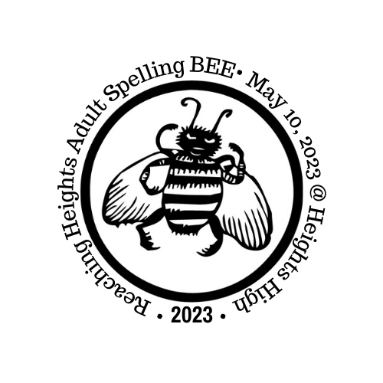
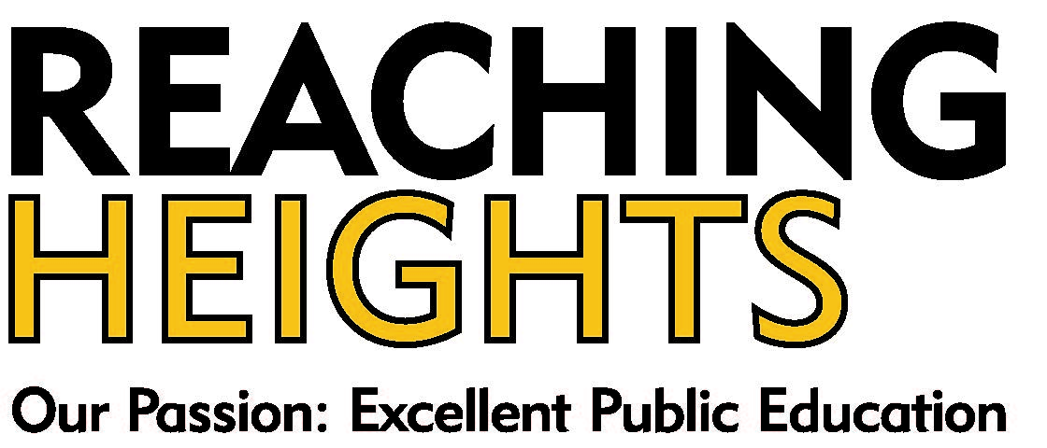

32nd Reaching Heights
Adult Community Spelling BEE
Team Registration Form

WHO: CH-UH PTAs will participate with Community Groups,
Businesses, Religious Institutions, City Councils, Non-profits,
Alumni, School Groups, Sports Teams, Music Groups,
Street Club’s and more.

WHEN: Wednesday, May 10th, 7 PM

WHERE: Heights High School Auditorium (13263 Cedar Road, Cleveland Heights 44118)
□ Yes!
Is your team planning
to spell this year?
□ We are working on it.
□ Sorry, can’t make it.
□ I’d like to just donate.

Team Name:

Contact Name:
Address:

Phone: E-mail:

Names of Spellers:

Alternate Name

□ Please reserve our spot; our $50 deposit is enclosed.
Make checks payable to Reaching Heights
□ Our minimum team commitment of $500 is enclosed.
□ We’ll also work to raise an additional $_________.

Join the fun and help us make this BEE the best BEE ever!

Questions? Contact Reaching Heights at 216-932-5110 or jen@reachingheights.org

Please respond by April 22, 2023. A maximum of 23 teams can compete on stage.

Please return registration form ASAP to secure your spot on stage!!
Reaching Heights, 2843 Washington Bl., Cleveland Hts., OH 44118

